Final Project Report
Course Title: Software Engineering Design Capstone Project
Course Code: SE 311


SUBMITTED TO:
Md. Rashedul Alam
Lecturer
Department of SWE
Daffodil International University

SUBMITTED BY:
MD. Shoaib Sikder
[Student ID]
Section: 40_G2
Department of SWE
Daffodil International University

💬 Postit
Final Project Documentation — Version 1.2
Project Documentation

Table of Contents
1. Executive Summary.................................................................3
2. Introduction.............................................................................3
3. Scenario Writing..........................................................................4
• Scenario-1: User Login / Registration................................................4
• Scenario-2: Profile Viewing / Editing with Media.....................................4
• Scenario-3: Create Post with Image Attachments.......................................4
• Scenario-4: Edit / Delete Post and Images...........................................4
• Scenario-5: Like / Unlike a Post....................................................5
• Scenario-6: Comment on a Post.......................................................5
• Scenario-7: Follow / Unfollow User..................................................5
• Scenario-8: Personalized Feed.......................................................5
• Scenario-9: Edit / Delete Own Comment...............................................5
• Scenario-10: Feed Refresh / Pagination..............................................5
• Scenario-11: User / Post Search with Filters........................................6
• Scenario-12: Notifications for Follow / Like / Comment...............................6
• Scenario-13: Mark Notification Read.................................................6
• Scenario-14: Admin Dashboard and System Monitoring..................................7
• Scenario-15: Admin User and Content Management......................................7
• Scenario-16: Admin Audit, Notification and System Control...........................7
4. Requirement Specification.............................................................8
5. System Design & Architecture..........................................................10
6. Technical Implementation...............................................................29
7. Quality Assurance & Testing............................................................34
8. Individual Contribution...............................................................37
9. Conclusion & Future Work...............................................................37
10. Appendices...............................................................................38

1. Executive Summary
Postit is a small social media web application built around the everyday actions expected from a social platform: creating an account, maintaining a profile, publishing posts, attaching images, following other users, and interacting through likes and comments. The enhanced version also introduces simple user and post search and a notification layer for follow, like, and comment activity.
The project is intentionally kept at a practical scale. Instead of adding a large number of social-media features, the implementation focuses on making a small set of connected features work properly from the browser to the API and finally to the database. This makes the project suitable for demonstrating software-engineering concepts such as requirements analysis, relational modeling, API design, validation, authorization, media handling, testing, and deployment.
Main Value Proposition:
- For Users: A straightforward place to publish short posts, share images, follow people, search for users or posts, and keep track of recent interactions.
- For the Project: A compact full-stack example where authentication, social relationships, media records, search queries, and notifications work together instead of appearing as unrelated CRUD screens.
Technology Stack:
- Frontend: HTML5, CSS3, and Vanilla JavaScript.
- Backend: Django with Django REST Framework.
- Database: PostgreSQL.
- Media: Local media storage during development, with object storage as a production option.
- Development Tools: Git, GitHub, VS Code, and Postman/Insomnia for API testing.

2. Introduction
2.1 Problem Statement: Many small social-media assignments stop after basic create, read, update, and delete screens. That does not fully represent how a social application behaves, because the useful part comes from the relationships between users, posts, interactions, media, and notifications. Postit addresses this by bringing those parts into one connected application.
2.2 Project Objectives:
- Implement a secure registration, login, and logout flow using Django authentication.
- Create user profiles with profile pictures, cover media, and optional profile media items.
- Allow users to create, edit, and delete their own posts and attach multiple images to posts.
- Implement likes, comments, and follow relationships with database-level uniqueness and ownership checks.
- Build a chronological feed containing the current user and followed users.
- Provide simple user and post search with useful filtering options.
- Generate notifications when another user follows, likes, or comments on a user’s content.
- Keep the frontend, backend, database, and media handling separated so each part can be maintained without unnecessary complexity.
2.3 System Boundaries (Scope):
- In-Scope: User registration and login, profile management, profile media, post creation and editing, post image attachments, comments, likes, follows, personalized feed, user search, post search and filtering, follow/like/comment notifications, administrator dashboard, account management, content moderation, media moderation, activity monitoring, notification oversight, and audit logging.
- Out-of-Scope: Private messaging, real-time chat, stories, reels, live video, payments, advanced recommendation systems, and large-scale content moderation.
2.4 Stakeholder Analysis:
- User: Needs a simple way to create a profile, publish content, follow people, search for relevant accounts or posts, and notice new interactions.
- Platform Administrator / Developer: Needs clear data rules, secure endpoints, safe media handling, and a code structure that can be maintained without unnecessary infrastructure.
Platform Administrator: Has responsibility for the overall operation of Postit. The administrator can monitor user activity and system statistics, manage user accounts, moderate posts, comments and media, inspect social relationships, review notification activity, and access audit records. Administrator actions are logged so that system-level changes remain traceable.
2.5 Admin Control Scope: The administrator is treated as a first-class system role rather than only a database administrator. The admin panel covers account management, content moderation, media control, activity monitoring, notification oversight, audit logging, and selected operational settings. These controls are protected by server-side permissions and are not granted simply because an admin link is visible in the browser.
- Project Evaluator: Needs to see a complete example covering frontend, backend, database, API, testing, media handling, search, and notification workflows.

3. Scenario Writing

Scenario-1: User Login / Registration
o Request Entry: User opens Postit and chooses to register or log in.
o Input Data: Username, email, password, and confirmation where required.
o Verification: The authentication service validates submitted information against the database.
o Success: A valid account creates an authenticated session and the user is taken to the main feed.

Scenario-2: Profile Viewing / Editing with Media
o Access: User opens their own profile or another user’s profile.
o Display: The system shows username, name, bio, profile picture, cover media where available, follower count, following count, and profile media.
o Edit Rule: Only the profile owner can change profile details or manage their own media.
o Save: The backend validates uploaded media and updates the profile records.

Scenario-3: Create Post with Image Attachments
o Initialization: User selects the create-post area.
o Data Entry: The user writes the post content and optionally selects one or more images.
o Validation: The server checks authentication, content length, file type, file size, and attachment limits.
o Commit: The post is stored first, followed by its related image records.

Scenario-4: Edit / Delete Post and Images
o Selection: User opens one of their own posts and chooses Edit or Delete.
o Ownership Check: The server confirms that the post belongs to the current user.
o Media Handling: The user may remove existing attachments and add new valid images while editing.
o Result: Updated records are returned, or the post and dependent records are removed according to the database rules.

Scenario-5: Like / Unlike a Post
o Interaction: User clicks the like button on a post.
o Validation: The system confirms that the user is authenticated and the post exists.
o Relationship: A unique like record is created for a new like or removed for an unlike action.
o Notification: When a new like is created, the post owner receives a notification unless the user is liking their own post.

Scenario-6: Comment on a Post
o Open: User expands the comment area of a post.
o Input: User writes a comment and submits it.
o Validation: The server checks authentication and comment content.
o Result: The comment is stored with the correct author and post, and a notification is created for the post owner when appropriate.

Scenario-7: Follow / Unfollow User
o Discovery: User opens another person’s profile.
o Action: User selects Follow or Unfollow.
o Rule Check: The system prevents self-following and duplicate follow relationships.
o Result: The relationship and follower count are updated; a follow notification is created for the target user when a new follow is made.

Scenario-8: Personalized Feed
o Trigger: User opens the home page.
o Selection: The backend identifies the current user and the accounts they follow.
o Query: Posts created by the current user and followed users are selected and ordered by latest creation time.
o Display: The frontend renders posts, attached images, like/comment counts, and pagination information.

Scenario-9: Edit / Delete Own Comment
o Selection: User chooses to modify or remove one of their comments.
o Ownership Check: The backend confirms that the logged-in user owns the comment.
o Action: Validated comment content is updated or the comment is deleted.
o Result: The comment section refreshes without changing another user’s content.

Scenario-10: Feed Refresh / Pagination
o Trigger: User refreshes the feed or reaches the end of the current page.
o Request: Frontend requests the selected page from the feed endpoint.
o Processing: Backend applies ordering, page size, and the current user’s follow relationships.
o Result: New records are returned without loading the entire post history at once.

Scenario-11: User / Post Search with Filters
o Input: User enters a search term and chooses a user or post search.
o Filtering: User search may filter by username or name, while post search may filter by text, author, and optional date range.
o Processing: Backend validates the query, performs a simple case-insensitive search, and applies pagination.
o Result: Matching users or posts are returned in a compact result list.

Scenario-12: Notifications for Follow / Like / Comment
o Trigger Event: A user follows another account, likes a post, or comments on a post.
o Event Handling: The backend identifies the recipient and notification type.
o Persistence: A notification record is created with actor, target information, type, and timestamp.
o Display: The recipient sees the notification in the notification area and unread count.

Scenario-13: Mark Notification Read
o Access: User opens the notification area.
o Selection: User selects an unread notification.
o Authorization: Backend verifies that the notification belongs to the current user.
o Update: The system changes is_read to true and returns the updated state.
o Dashboard Entry: Administrator signs in using an account with the admin role and opens the administration dashboard.
o Summary Data: The system displays user counts, active accounts, posts, comments, likes, follows, media records, notifications, and recent activity.
o Monitoring: Admin can inspect recent system activity and statistics without changing user data.
o Access Control: Only authorized administrators can access the dashboard and its monitoring APIs.
o Audit Trail: Each administrative change produces an audit entry containing the administrator, target record, action, and timestamp.
o System Control: Admin can manage approved operational limits such as media attachment limits or account availability where those controls are exposed by the application.
o Notification Oversight: Admin can inspect notification volume and notification records and remove invalid system-generated records when required.
o Activity Review: Admin opens audit logs to inspect who performed a system-level action, what was affected, and when it happened.

Scenario-16: Admin Audit, Notification and System Control
o Protection: The backend verifies admin permission on every moderation request and records the action.
o Content Moderation: Admin can review and remove inappropriate posts, comments, and uploaded media when necessary.
o Account Action: Admin can deactivate, reactivate, ban, or unban an account according to the platform rules.
o User Review: Admin searches or filters user accounts and opens a user record.

Scenario-15: Admin User and Content Management
o Access Control: Only authorized administrators can access the dashboard and its monitoring APIs.
o Monitoring: Admin can inspect recent system activity and statistics without changing user data.
o Summary Data: The system displays user counts, active accounts, posts, comments, likes, follows, media records, notifications, and recent activity.
o Dashboard Entry: Administrator signs in using an account with the admin role and opens the administration dashboard.

Scenario-14: Admin Dashboard and System Monitoring

4. Requirement Specification

4.1 Functional Requirements (FR):
ID | Feature | Description | Stakeholders
FR01 | User Registration | Secure account creation with unique username/email and password validation. | Users, Developers
FR02 | User Login / Logout | Authenticated access using Django sessions and clear error handling. | Users
FR03 | Profile Management | Users can view and update their personal information and biography. | Users
FR04 | Profile Media | Users can maintain profile picture, cover media, and additional profile media items. | Users
FR05 | Post Creation | Authenticated users can publish text posts. | Users
FR06 | Post Editing / Deletion | Users can modify or remove only the posts they own. | Users, Developers
FR07 | Post Image Attachments | Users can attach multiple validated images to a post and manage them later. | Users
FR08 | Comment Management | Users can create comments and manage only their own comments. | Users
FR09 | Like / Unlike | Users can like or unlike a post; duplicate likes are prevented. | Users
FR10 | Follow / Unfollow | Users can follow or unfollow other users; self-follow is prohibited. | Users
FR11 | Personalized Feed | System shows own posts and posts from followed users with pagination. | Users
FR12 | User Search | Users can search accounts by username or name. | Users
FR13 | Post Search | Users can search posts by text and inspect matching results. | Users
FR14 | Search Filtering | Post search can be narrowed by author and optional date range. | Users
FR15 | Follow / Like / Comment Notifications | System creates notifications for relevant social interactions. | Users
FR16 | Notification Read State | Users can view unread notifications and mark notifications as read. | Users
FR17 | Media Validation | Uploaded files must pass supported type, size, and basic safety checks. | Users, Developers
FR18 | Pagination | Post, comment, search, and notification lists are paginated where needed. | Users, Developers
FR19 | Authorization / Ownership | Protected operations must verify authentication and ownership before changing data. | Users, Developers
FR20 | Admin Dashboard | Administrator can view system-wide counts, recent activity, and operational summaries. | Admins
FR21 | User Management | Administrator can search, inspect, activate, deactivate, ban, and unban user accounts while preserving audit history. | Admins
FR22 | Post Moderation | Administrator can inspect and remove any post that violates platform rules. | Admins
FR23 | Comment Moderation | Administrator can inspect and remove any comment when moderation is required. | Admins
FR24 | Media Moderation | Administrator can inspect and remove post/profile media that is invalid or inappropriate. | Admins
FR25 | Relationship Monitoring | Administrator can inspect follow activity and social relationship counts for monitoring purposes. | Admins
FR26 | Notification Administration | Administrator can monitor notification activity and manage system-level notification records where necessary. | Admins
FR27 | Audit Logging | Every administrator action must create a traceable audit record containing actor, target, action, and timestamp. | Admins, Developers
FR28 | Search & Activity Monitoring | Administrator can inspect aggregate search and platform activity information to support moderation and system monitoring. | Admins
FR29 | System Controls | Administrator can manage exposed operational limits and account availability controls without changing application source code. | Admins

4.2 Non-Functional Requirements (NFR):
- Security: Authentication, authorization, CSRF protection, safe rendering, file validation, and ownership checks are required for all state-changing operations.
- Usability: Search, profile, post, and notification controls should be understandable without additional instructions.
- Performance: Feed, search, comment, and notification lists should use pagination and efficient queries.
- Reliability: Database constraints should prevent duplicate likes and follows, and invalid media should never be accepted as trusted content.
- Maintainability: Django apps, API functions, JavaScript modules, and business rules should be separated into understandable units.
- Compatibility: The web interface should work on current desktop and mobile browsers.
• Auditability: Administrative actions must be recorded with an administrator identity, action, target resource, and timestamp so that system changes can be reviewed later.
• Access Control: Admin APIs must be protected on the server. A normal authenticated user must never gain admin access by editing frontend navigation or request parameters.
• Moderation Safety: Removing an account or content should use clear confirmation and predictable deletion rules so that accidental system-wide changes are minimized.
• Operational Visibility: The administration dashboard should present enough information to identify unusual activity, growing data volume, and recent moderation actions.

5. System Design & Architecture

5.1 System Architecture Diagram:
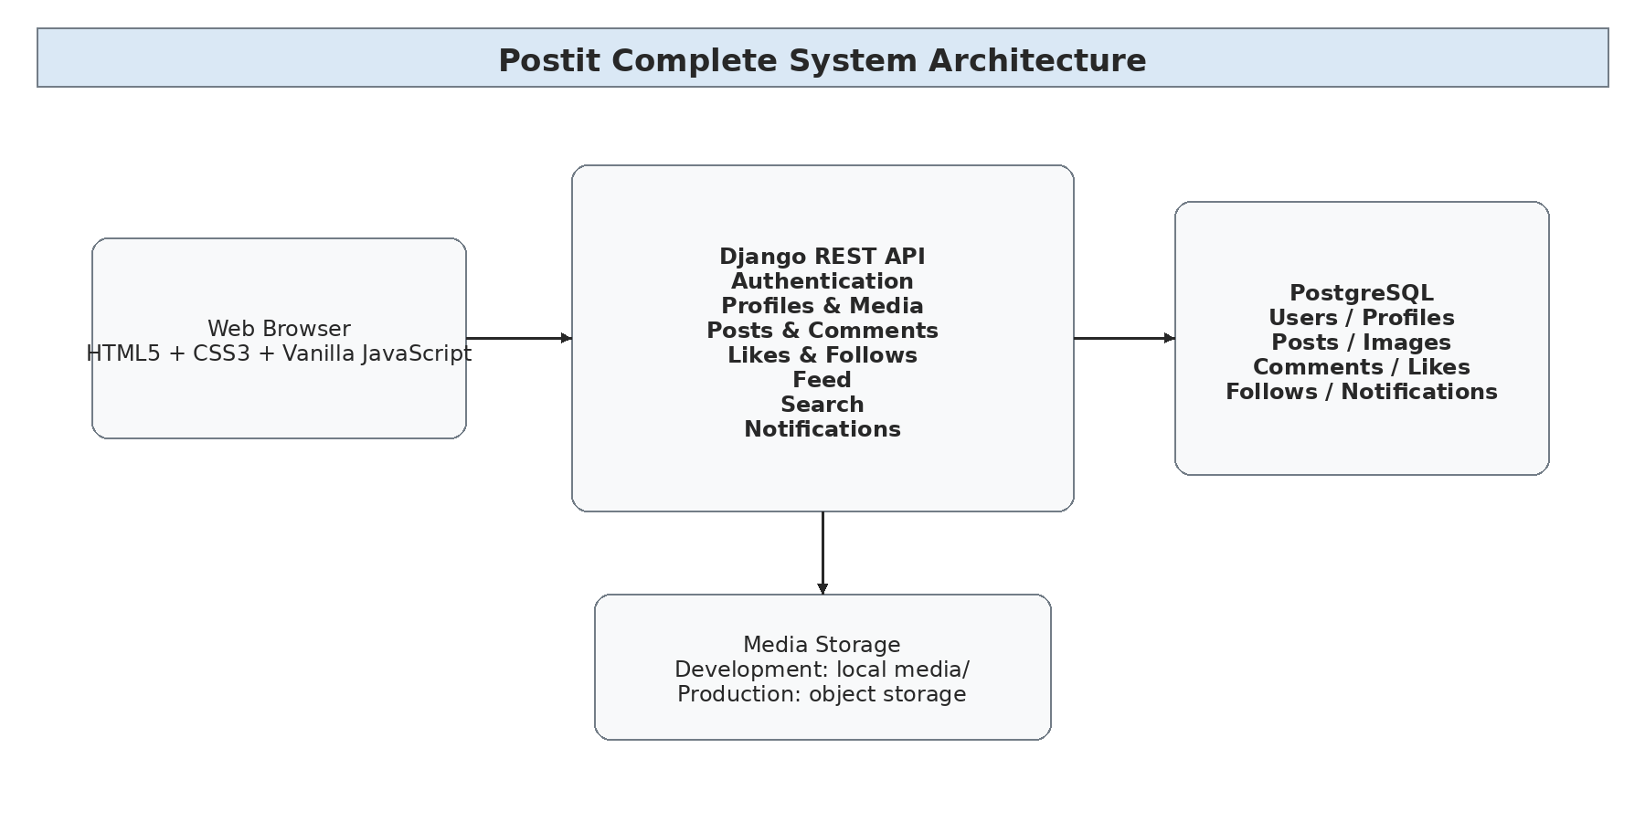
Figure 5.1: Postit Complete System Architecture

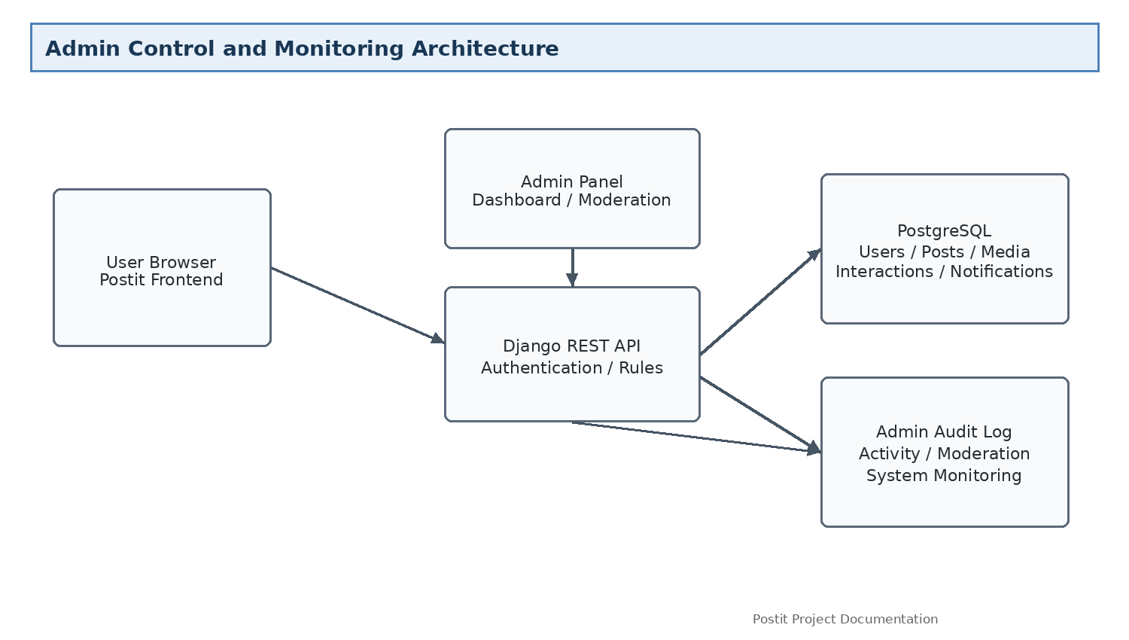
Figure 5.1.1: Admin Control and Monitoring Architecture

5.2 System Modeling:

Use Case Diagram:
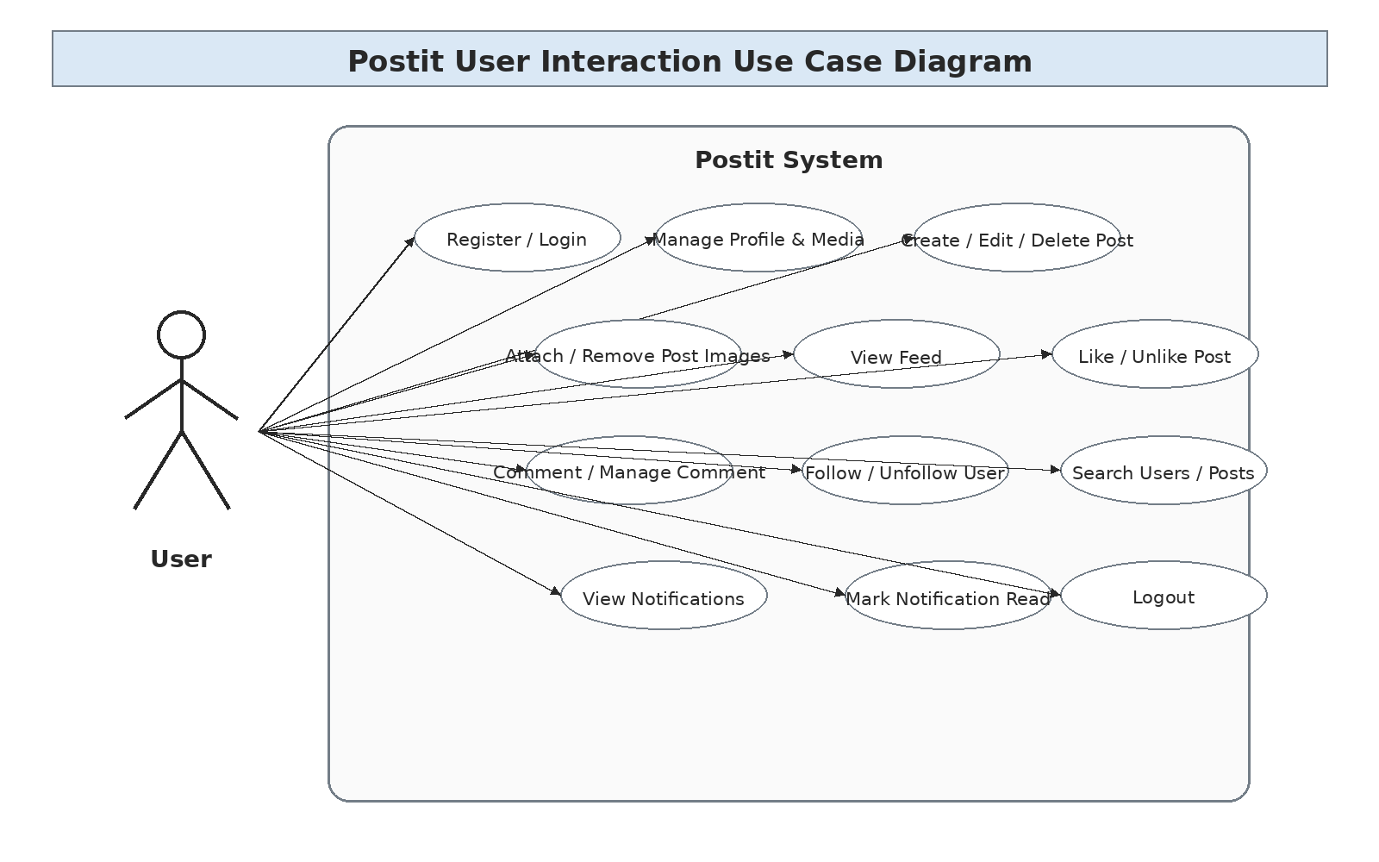
Figure 5.2: Postit User Interaction Use Case Diagram

Admin Control Use Case Diagram:
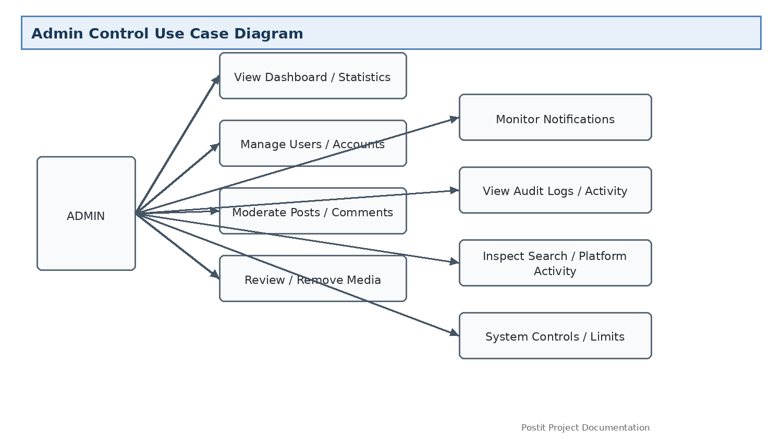

Activity Diagrams:

Scenario-1: User Login / Registration
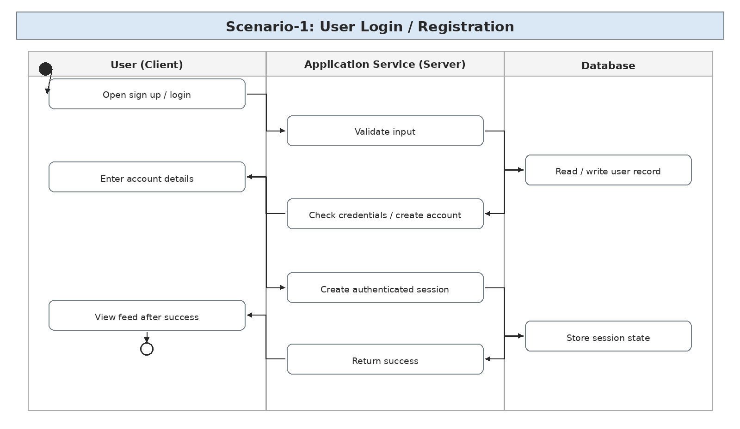
Figure 5.2.1: Scenario-1: User Login / Registration

Scenario-2: Profile Viewing / Editing with Media
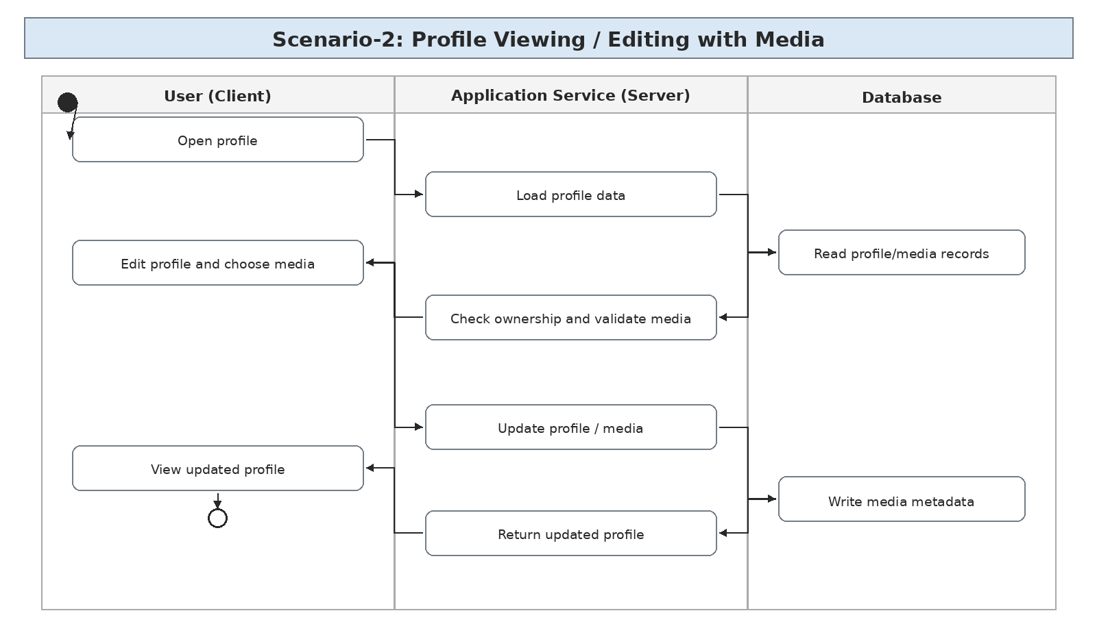
Figure 5.2.2: Scenario-2: Profile Viewing / Editing with Media

Scenario-3: Create Post with Image Attachments
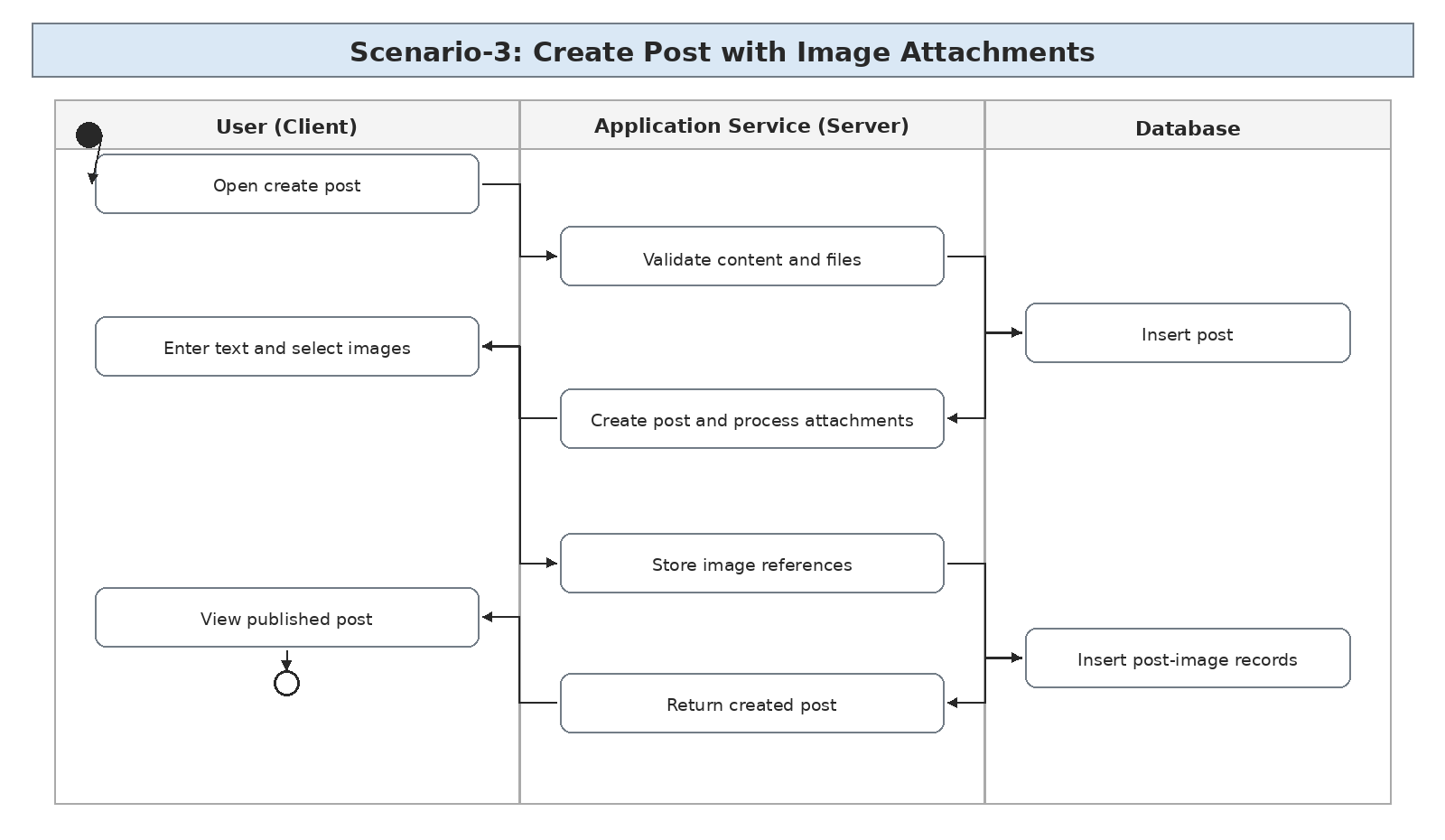
Figure 5.2.3: Scenario-3: Create Post with Image Attachments

Scenario-4: Edit / Delete Post and Images
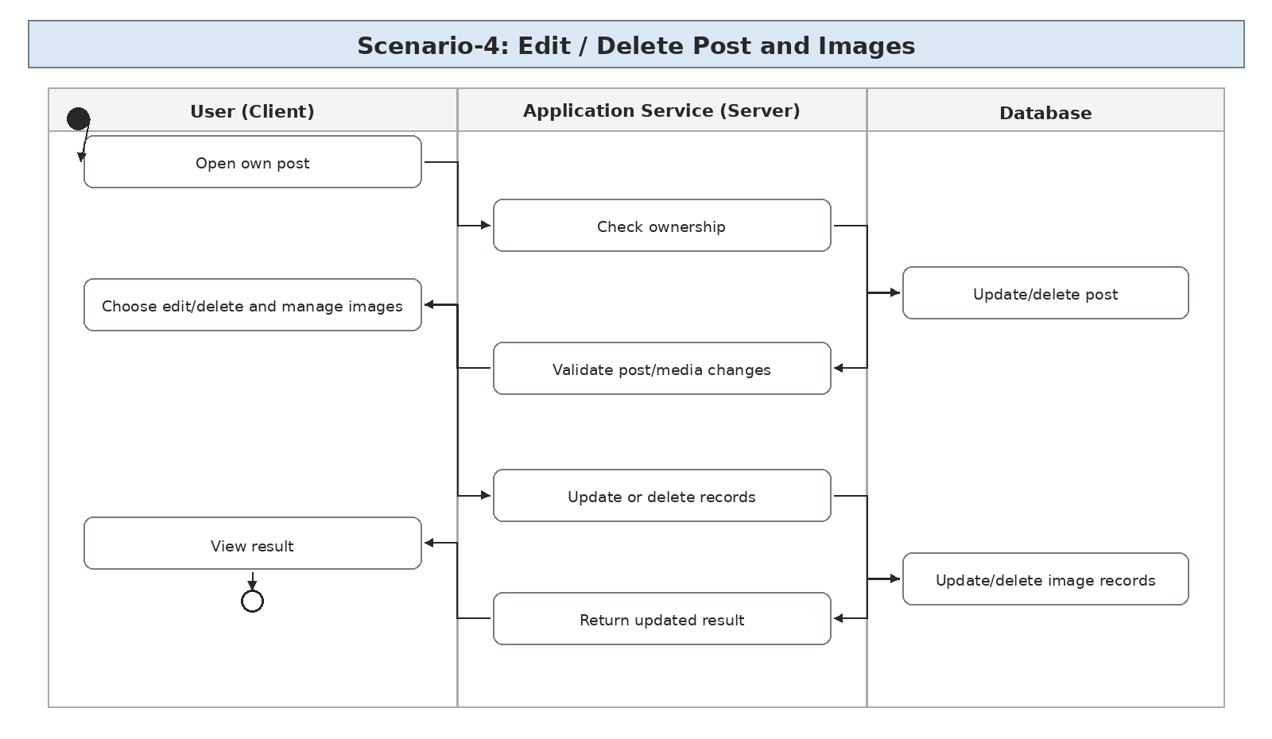
Figure 5.2.4: Scenario-4: Edit / Delete Post and Images

Scenario-5: Like / Unlike a Post
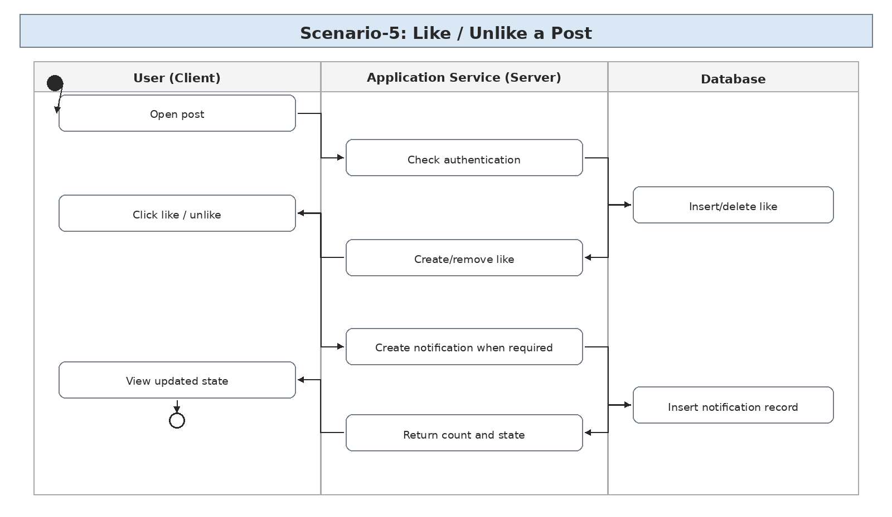
Figure 5.2.5: Scenario-5: Like / Unlike a Post

Scenario-6: Comment on a Post
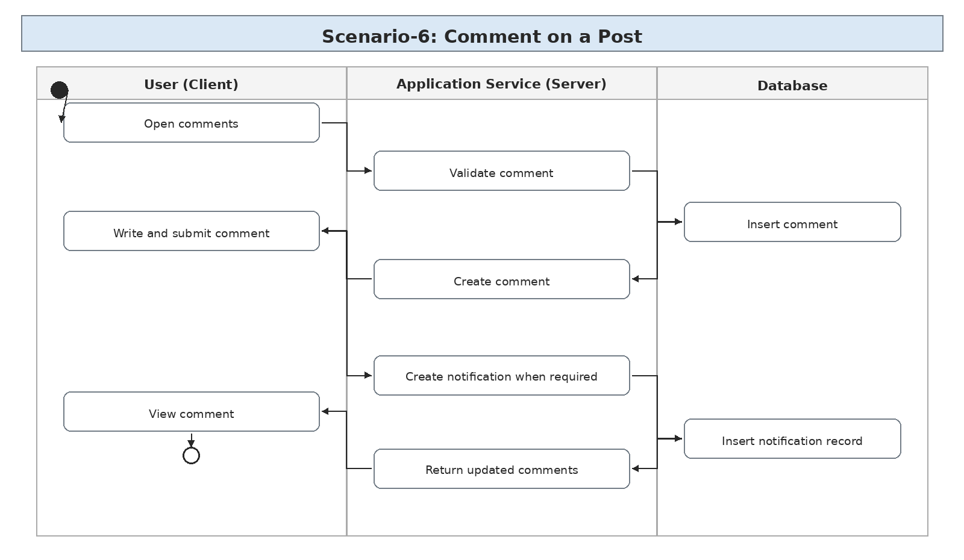
Figure 5.2.6: Scenario-6: Comment on a Post

Scenario-7: Follow / Unfollow User
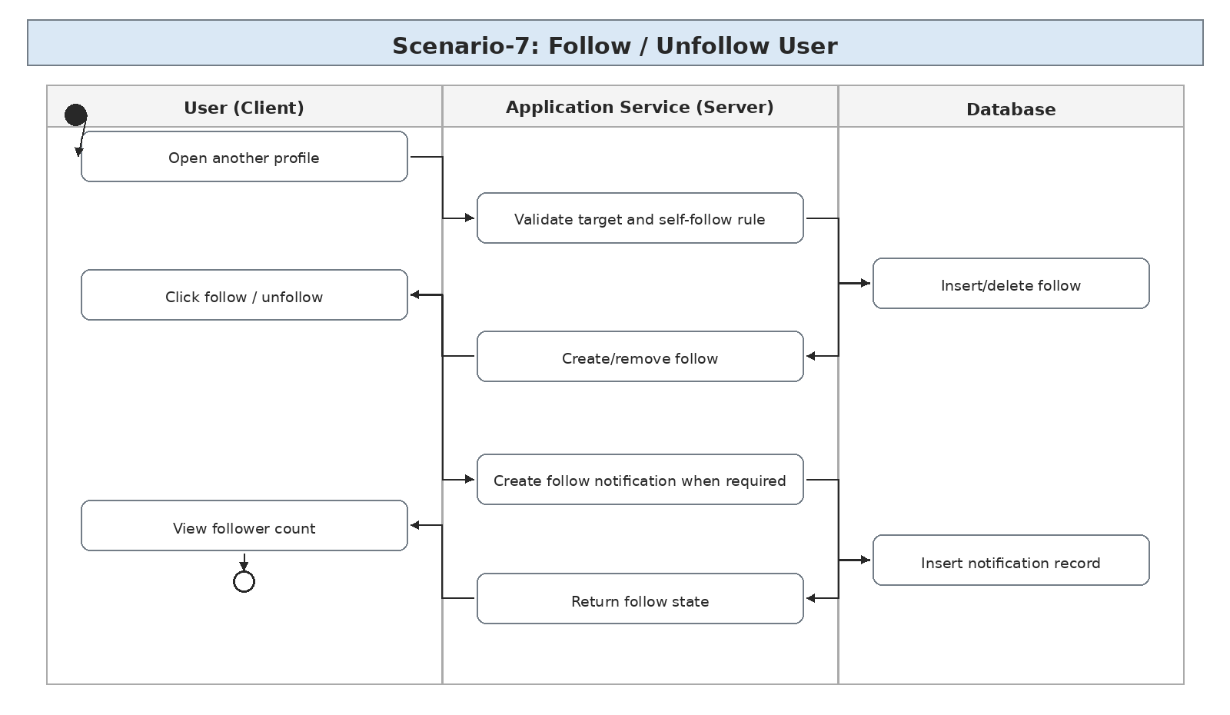
Figure 5.2.7: Scenario-7: Follow / Unfollow User

Scenario-8: Personalized Feed
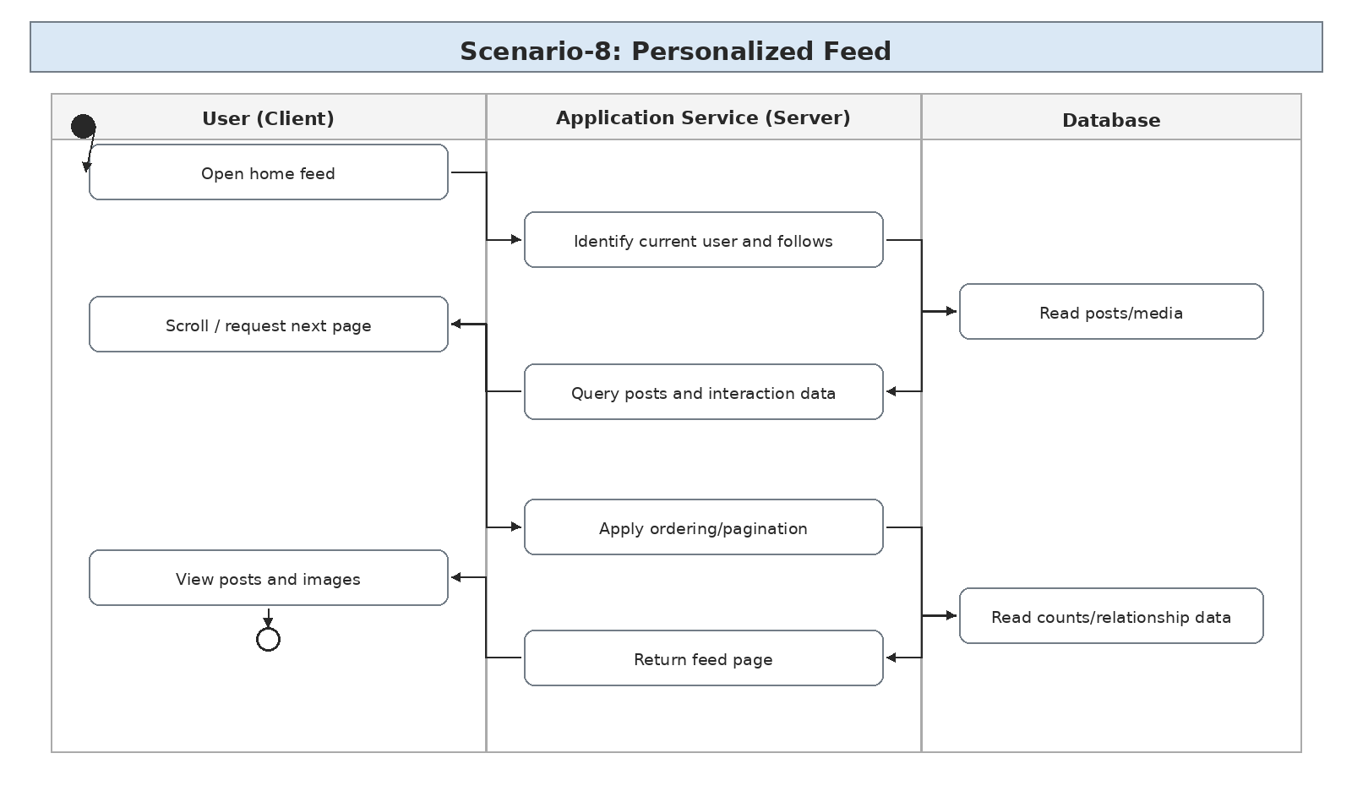
Figure 5.2.8: Scenario-8: Personalized Feed

Scenario-9: Edit / Delete Own Comment
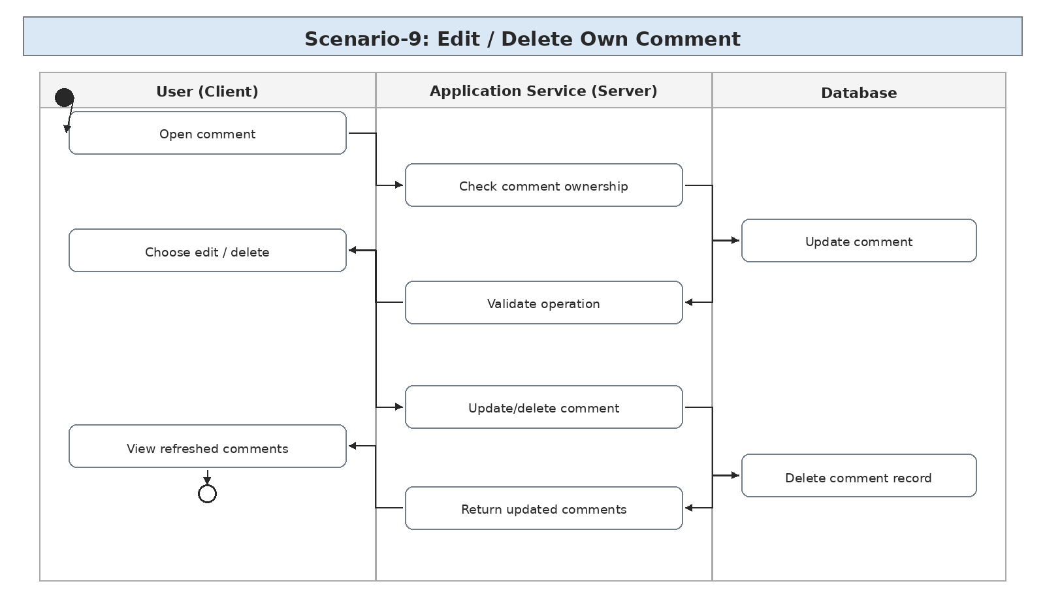
Figure 5.2.9: Scenario-9: Edit / Delete Own Comment

Scenario-10: Feed Refresh / Pagination
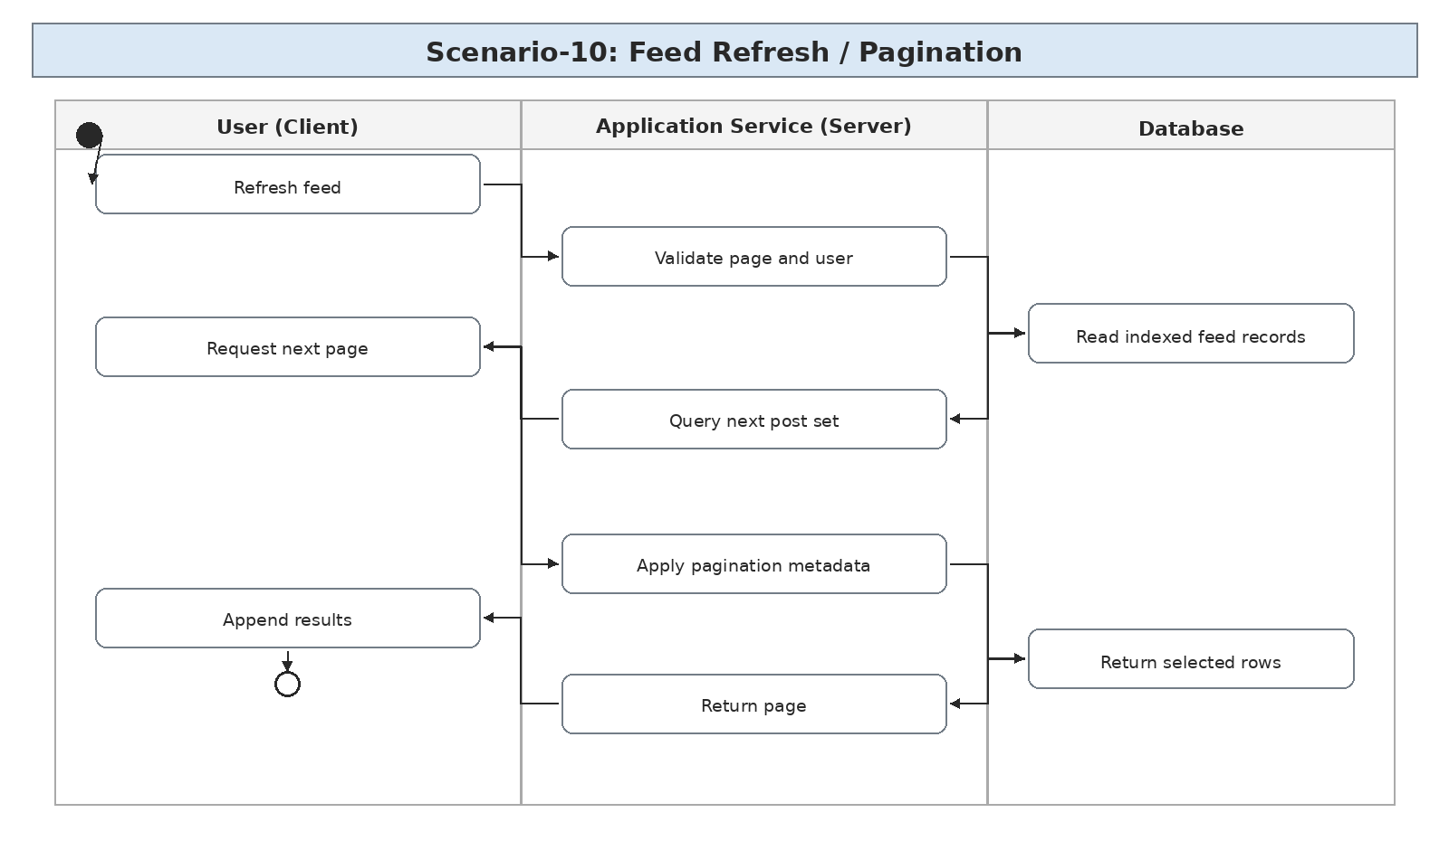
Figure 5.2.10: Scenario-10: Feed Refresh / Pagination

Scenario-11: User / Post Search with Filters
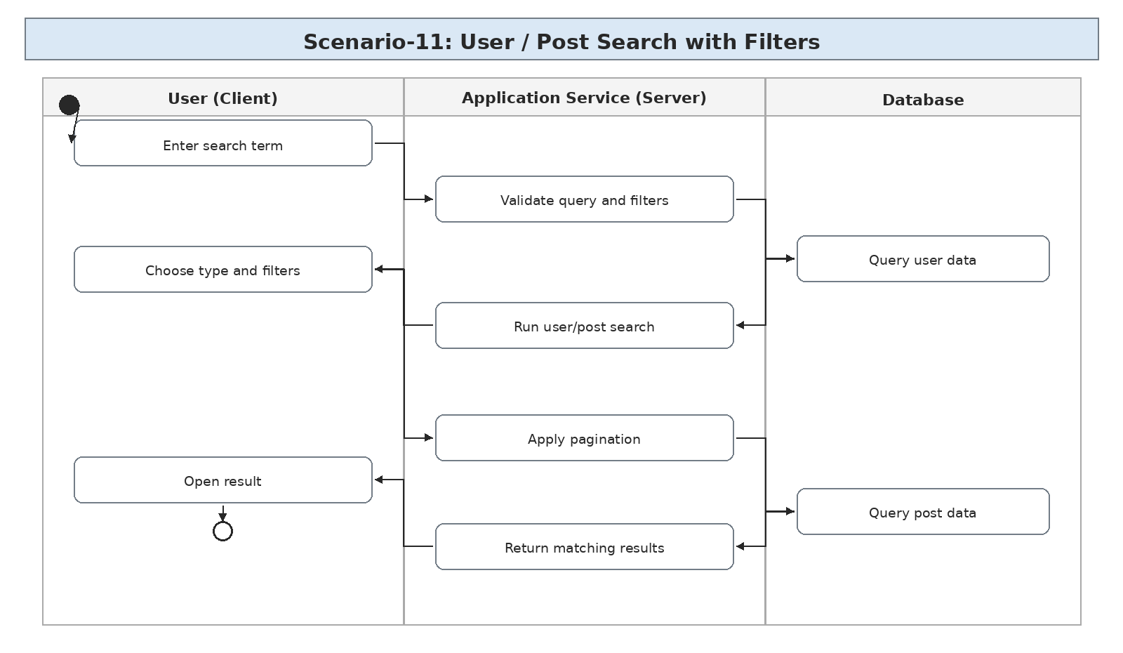
Figure 5.2.11: Scenario-11: User / Post Search with Filters

Scenario-12: Notifications for Follow / Like / Comment
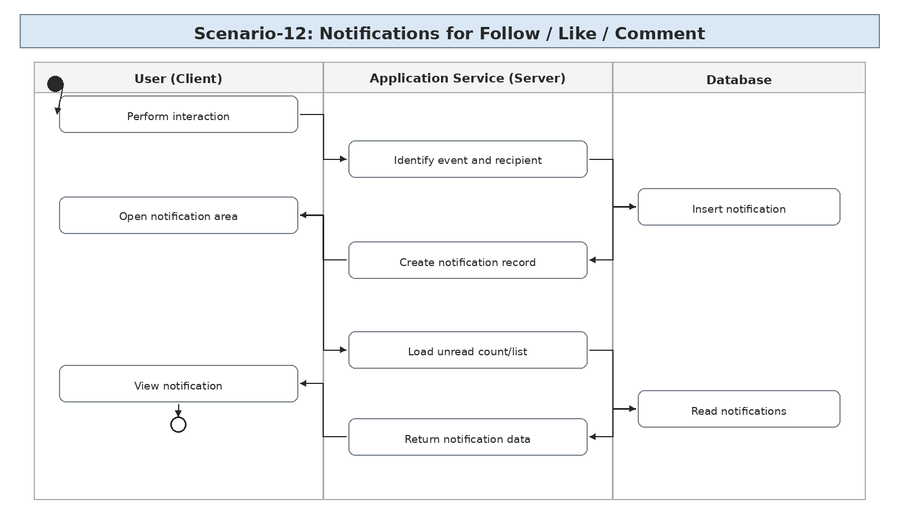
Figure 5.2.12: Scenario-12: Notifications for Follow / Like / Comment

Scenario-13: Mark Notification Read
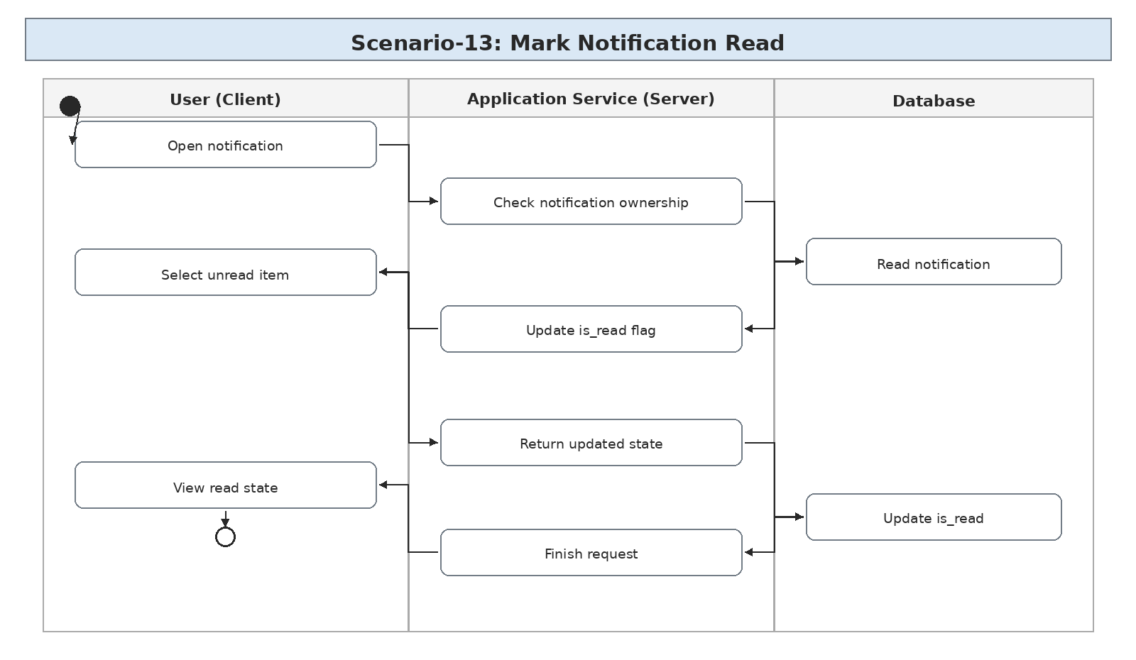
Figure 5.2.13: Scenario-13: Mark Notification Read

Scenario-14: Admin Dashboard and System Monitoring

Scenario-15: Admin User and Content Management
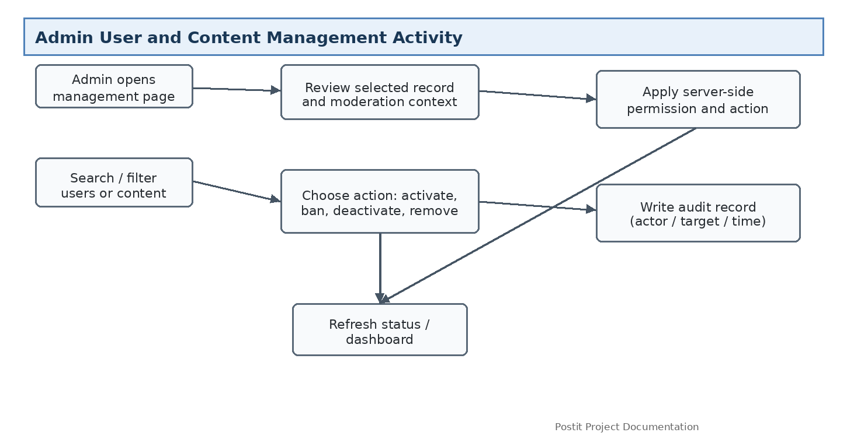

Scenario-16: Admin Audit, Notification and System Control
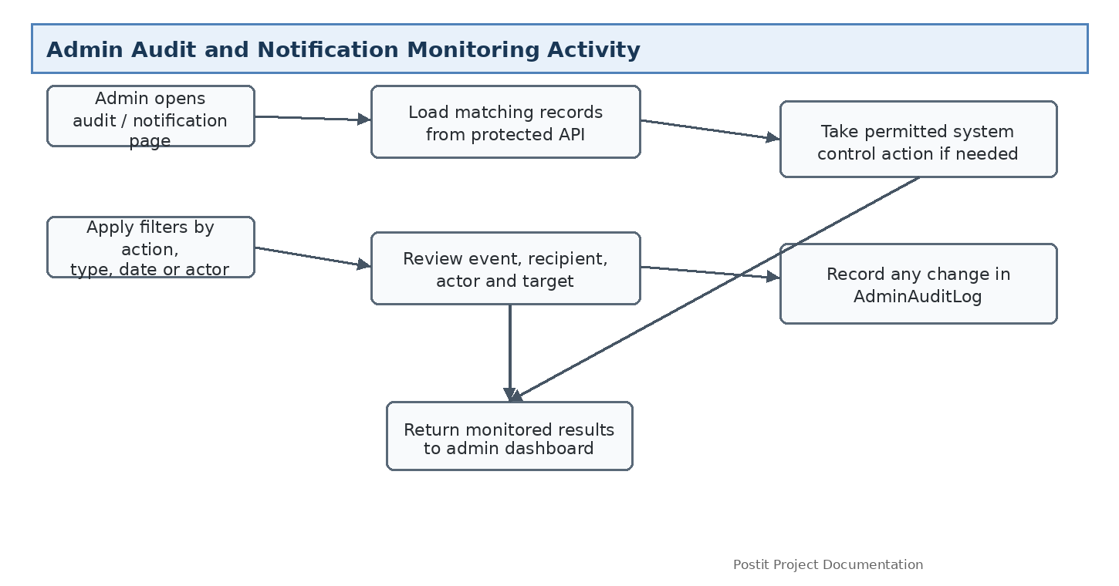

5.3 Database Design:

Entity Relationship Diagram (ERD):
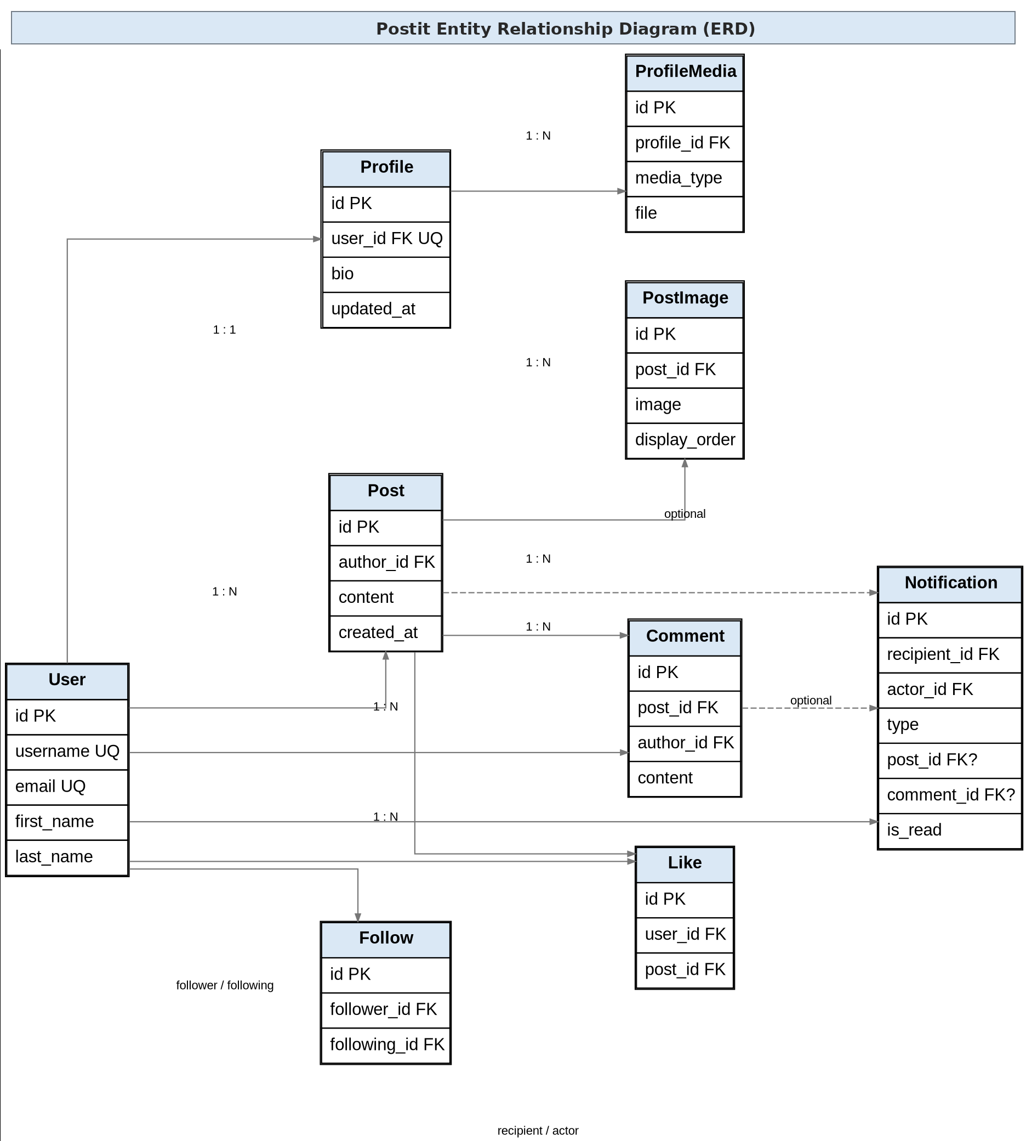
Figure 5.3: Postit Entity Relationship Diagram

Data Dictionary:

User Table:
Field Name | Data Type | Constraints | Description
id | BIGINT | PK | Unique identifier for each user.
username | VARCHAR | Unique | Public username used for login/search.
email | EMAIL | Unique | Email address associated with the account.
password | VARCHAR | Not Null | Django-managed hashed password value.
first_name | VARCHAR | Optional | User first name.
last_name | VARCHAR | Optional | User last name.
date_joined | DT | Not Null | Timestamp when the account was created.
is_active | BOOLEAN | Default: True | Account availability flag.
role | VARCHAR(20) | Default: user | Defines whether the account is a normal user or an administrator.

Profile Table:
Field Name | Data Type | Constraints | Description
id | BIGINT | PK | Unique profile identifier.
user_id | FK | User(id), Unique | Links one profile to one user.
bio | TEXT | Nullable | Short user biography.
updated_at | DT | Not Null | Last profile update time.

ProfileMedia Table:
Field Name | Data Type | Constraints | Description
id | BIGINT | PK | Unique profile media identifier.
profile_id | FK | Profile(id) | Profile that owns the media item.
media_type | VARCHAR | Not Null | profile_picture, cover, or gallery.
file | FILE/URL | Not Null | Stored media file or storage path.
created_at | DT | Not Null | Upload timestamp.

Post Table:
Field Name | Data Type | Constraints | Description
id | BIGINT | PK | Unique post identifier.
author_id | FK | User(id) | User who created the post.
content | TEXT | Not Null | Main post text.
created_at | DT | Not Null | Creation timestamp.
updated_at | DT | Not Null | Last edit timestamp.

PostImage Table:
Field Name | Data Type | Constraints | Description
id | BIGINT | PK | Unique image identifier.
post_id | FK | Post(id) | Post to which the image belongs.
image | FILE/URL | Not Null | Stored image file or storage path.
alt_text | VARCHAR | Optional | Alternative text for accessibility.
display_order | INT | Default: 0 | Controls image order in the post gallery.
created_at | DT | Not Null | Upload timestamp.

Comment Table:
Field Name | Data Type | Constraints | Description
id | BIGINT | PK | Unique comment identifier.
post_id | FK | Post(id) | Post receiving the comment.
author_id | FK | User(id) | User who wrote the comment.
content | TEXT | Not Null | Comment body.
created_at | DT | Not Null | Creation timestamp.
updated_at | DT | Not Null | Last edit timestamp.

Like Table:
Field Name | Data Type | Constraints | Description
id | BIGINT | PK | Unique like identifier.
user_id | FK | User(id) | User who liked the post.
post_id | FK | Post(id) | Post that received the like.
created_at | DT | Not Null | Like timestamp.

Follow Table:
Field Name | Data Type | Constraints | Description
id | BIGINT | PK | Unique follow relationship identifier.
follower_id | FK | User(id) | User who follows another account.
following_id | FK | User(id) | User being followed.
created_at | DT | Not Null | Relationship creation time.

Notification Table:
Field Name | Data Type | Constraints | Description
id | BIGINT | PK | Unique notification identifier.
recipient_id | FK | User(id) | User who receives the notification.
actor_id | FK | User(id) | User who caused the event.
type | VARCHAR | Not Null | follow, like, or comment.
post_id | FK | Nullable | Related post when applicable.
comment_id | FK | Nullable | Related comment when applicable.
is_read | BOOLEAN | Default: False | Whether the recipient has opened the notification.
created_at | DT | Not Null | Notification creation timestamp.

AdminAuditLog Table:
Field Name | Data Type | Constraints | Description
id | BIGINT | PK | Unique audit entry identifier.
admin_id | FK | User(id) | Administrator account responsible for the action.
action | VARCHAR(100) | Not Null | Action performed, such as ban user, delete post, or deactivate account.
target_type | VARCHAR(50) | Not Null | Type of resource affected, such as User, Post, Comment, Media, or Notification.
target_id | BIGINT | Nullable | Identifier of the affected resource when applicable.
details | JSON/TEXT | Nullable | Short structured description of the action or moderation reason.
ip_address | VARCHAR | Nullable | Request IP captured for administrative traceability where configured.
created_at | DT | Not Null | Timestamp of the administrative action.
Administrator accounts are identified through the User.role field and checked server-side before protected admin operations.
A normal user cannot access admin endpoints even if the admin URL is manually entered in the browser.
Administrative actions on users, posts, comments, media, or notification records are recorded in AdminAuditLog.
The system must protect against deleting or deactivating the last active administrator account.
Admin audit records should be append-oriented so that normal users cannot modify or delete them.

Database Integrity Rules:
- A user can have only one profile.
- A user cannot like the same post more than once.
- A user cannot follow themselves or create the same follow relationship more than once.
- Deleting a post should cascade or otherwise safely remove its comments, likes, images, and related notification references according to the chosen Django deletion rules.
- Notification ownership is enforced through recipient_id. Users cannot mark another user’s notification as read.
- Media references must remain linked to an existing profile or post.

6. Technical Implementation

6.1 Backend / Data Interaction Documentation:

6.1.1 Backend Organization
The backend of Postit is planned as a Django project with small applications for authentication, profiles, media, posts, comments, likes, follows, feed, search, and notifications. Each part has a clear responsibility, while the database remains the source of truth for relationships and ownership. This keeps the project close to the structure used in the rest of the application rather than introducing infrastructure that is not needed for a small social platform.
backend/
├── accounts/ # Registration, login, session management
│ ├── admin.py
│ ├── apps.py
│ ├── migrations/
│ ├── serializers.py
│ ├── tests.py
│ ├── urls.py
│ ├── views.py
│ └── __init__.py
├── profiles/ # Profile data and profile endpoints
├── media/ # Profile media and post image handling
├── posts/ # Post CRUD and ownership checks
├── comments/ # Comment CRUD and ownership checks
├── likes/ # Like / unlike relationships
├── follows/ # Follow / unfollow relationships
├── feed/ # Feed queries and pagination
├── search/ # User / post search and filtering
├── notifications/ # Follow / like / comment notifications
├── config/ # Django settings, URLs, ASGI/WSGI
├── manage.py # Django CLI utility
├── requirements.txt # Python dependencies
├── media/ # Development media files
└── .env # Environment configuration (not committed)

6.1.2 RESTful API Endpoints
Module | HTTP Method | Endpoint | Purpose | Request Body | Response | Authentication
Accounts | POST | /api/accounts/register/ | User registration | {username,email,password} | {user_id,username,email} | None
Accounts | POST | /api/accounts/login/ | User login | {username,email,password} | {user,authenticated} | None
Accounts | POST | /api/accounts/logout/ | User logout | None | {message} | Required
Profiles | GET | /api/users/<username>/ | View profile | None | {profile,media,counts} | Optional
Profiles | PATCH | /api/users/me/ | Update own profile | multipart/form-data | {profile,media} | Required
Media | POST | /api/posts/<id>/images/ | Attach post images | images[] | {images[]} | Required (Owner)
Media | DELETE | /api/posts/<id>/images/<image_id>/ | Remove post image | None | {message} | Required (Owner)
Posts | POST | /api/posts/ | Create post | multipart/form-data | {post,images} | Required
Posts | PATCH | /api/posts/<id>/ | Edit own post | multipart/form-data | {post,images} | Required (Owner)
Posts | DELETE | /api/posts/<id>/ | Delete own post | None | {message} | Required (Owner)
Comments | POST | /api/posts/<id>/comments/ | Add comment | {content} | {comment} | Required
Likes | POST | /api/posts/<id>/like/ | Like post | None | {liked,count} | Required
Likes | DELETE | /api/posts/<id>/like/ | Unlike post | None | {liked,count} | Required
Follows | POST | /api/users/<username>/follow/ | Follow user | None | {following,count} | Required
Follows | DELETE | /api/users/<username>/follow/ | Unfollow user | None | {following,count} | Required
Feed | GET | /api/feed/?page=1 | Get personalized feed | Query: page | {count,next,results[]} | Required
Search | GET | /api/search/users/?q= | Search users | Query: q,page | {results[]} | Optional
Search | GET | /api/search/posts/?q=&author=&from=&to= | Search/filter posts | Query: q,author,from,to,page | {results[]} | Optional
Notifications | GET | /api/notifications/ | Get notifications | Query: page | {count,unread,results[]} | Required
Notifications | POST | /api/notifications/<id>/read/ | Mark notification read | None | {is_read:true} | Required
Notifications | POST | /api/notifications/read-all/ | Mark all as read | None | {message} | Required
Admin | GET | /api/admin/dashboard/ | Get system-wide statistics and recent activity | None | {users,posts,comments,likes,follows,media,notifications,recent_activity} | Admin
Admin | GET | /api/admin/users/ | Search/filter users for account management | Query: q,status,page | {count,results[]} | Admin
Admin | POST | /api/admin/users/<id>/ban/ | Ban user account | {reason?} | {user,is_banned:true} | Admin
Admin | POST | /api/admin/users/<id>/unban/ | Remove user ban | None | {user,is_banned:false} | Admin
Admin | POST | /api/admin/users/<id>/deactivate/ | Temporarily deactivate account | {reason?} | {user,is_active:false} | Admin
Admin | POST | /api/admin/users/<id>/activate/ | Reactivate account | None | {user,is_active:true} | Admin
Admin | DELETE | /api/admin/posts/<id>/ | Moderate/remove any post | {reason?} | {message} | Admin
Admin | DELETE | /api/admin/comments/<id>/ | Moderate/remove any comment | {reason?} | {message} | Admin
Admin | DELETE | /api/admin/media/<id>/ | Remove inappropriate media | {reason?} | {message} | Admin
Admin | GET | /api/admin/audit-logs/ | Review administrative actions | Query: actor,action,target,page | {count,results[]} | Admin
Admin | GET | /api/admin/notifications/ | Monitor notification activity | Query: type,read,page | {count,results[]} | Admin
Admin | GET | /api/admin/activity/ | View aggregate platform activity | Query: from,to,type | {stats,results[]} | Admin

6.1.3 Media Handling Rules
- Post creation and profile updates use multipart/form-data when files are included.
- The server validates MIME type, file extension, size, and configured attachment limits before saving media metadata.
- The database stores references to media rather than placing binary image data directly in regular text fields.
- In development, files may be stored under media/. A production deployment can move the same storage layer to an object-storage service without changing the public API contract.
- Uploaded media should be served through controlled URLs and never be treated as trusted executable content.

6.1.4 Search Implementation
The initial search feature is deliberately simple. User search uses case-insensitive matching against username and display name. Post search uses the post content and can optionally narrow results by author and date range. Pagination is applied to avoid returning large result sets. More advanced ranking or PostgreSQL full-text search can be introduced later if the application grows.

6.1.5 Notification Rules
Notifications are generated by application events rather than by the frontend. A follow creates a notification for the followed user. A new like creates a notification for the post author. A new comment creates a notification for the post author. The system does not create a notification for a user’s own action on their own content. The first implementation uses normal API retrieval and does not require WebSockets.

6.1.6 Admin Control and Monitoring
The admin panel is the operational control layer of Postit. It is separate from normal user pages and is protected by a server-side admin permission check. The frontend only exposes controls that the logged-in administrator is allowed to use; the final decision is always made by Django on the API request.
Admin dashboard information includes total users, active/deactivated accounts, number of posts, comments, likes, follows, stored media, notification volume, and recent administrative actions. These values are intended for monitoring rather than replacing the database as the source of truth.
User management covers account search, status inspection, ban/unban, activation/deactivation, and viewing relevant public profile information. Password hashes and other authentication secrets are never displayed through the admin API.
Content moderation covers posts, comments, and uploaded media. An administrator can remove content when required by the platform rules. Destructive actions should require confirmation and a short reason so the audit trail remains understandable.
Administrative audit logging records the administrator, action, target resource, optional reason/details, IP address where configured, and timestamp. This gives the project a clear history of system-level changes.
The admin layer also supports monitoring of notification activity and aggregate search/platform activity. Detailed private user data should only be exposed where necessary for the administrative function.

6.2 Relationship & Access Rules:
Role / State | Key Permissions | Restricted Actions
Registered User | Register/Login, manage own profile/media, create/edit/delete own posts, attach images, comment, like, follow, search, view notifications | Cannot edit another user’s profile/post/comment, cannot access another user’s notifications, cannot follow self.
Unauthenticated Visitor | Open public login/registration pages and submit registration/login | Cannot create posts, comments, likes, follows, private profile updates, or notifications.
System Administrator | View dashboard and activity; manage user status; moderate posts/comments/media; inspect follows; monitor notifications and search activity; review audit logs; manage exposed operational limits. | Cannot directly view or alter password hashes; cannot remove the last active administrator account; all destructive actions require confirmation and are audited.

6.3 Frontend Organization:
The Postit frontend uses plain HTML, CSS, and JavaScript, but files are separated by responsibility. The API layer handles requests, while feature-specific modules manage feed rendering, media previews, search results, and notifications. This keeps the code understandable without introducing a frontend framework for a project that does not require one.
frontend/
├── index.html # Home / feed page
├── login.html # User login
├── register.html # Account registration
├── profile.html # User profile view/edit
├── search.html # User / post search page
├── notifications.html # Notification list
├── css/
│ ├── base.css # Base typography and reset
│ ├── layout.css # Page and responsive layout
│ ├── components.css # Reusable UI styles
│ └── responsive.css # Mobile / tablet adjustments
└── js/
├── api.js # Central API communication
├── auth.js # Login, register, logout
├── feed.js # Feed loading and pagination
├── profile.js # Profile view/edit and media
├── posts.js # Post creation/edit/delete + images
├── comments.js # Comment interactions
├── likes.js # Like / unlike logic
├── follows.js # Follow / unfollow logic
├── search.js # Search and filtering
├── notifications.js # Notification loading/read state
├── media.js # Preview/validation helpers
├── ui.js # Loading, errors, messages
└── main.js # Page initialization

6.4 Administration Frontend Organization
The admin frontend is kept separate from the normal social feed pages. The dashboard is designed for monitoring first, with dedicated screens for users, content, media, notifications, and audit logs. The admin interface should not rely on hidden links for security; every action is protected again by the backend.
frontend/
├── admin/
│ ├── dashboard.html # System statistics and recent activity
│ ├── users.html # User search, status and account actions
│ ├── posts.html # Post moderation
│ ├── comments.html # Comment moderation
│ ├── media.html # Profile/post media review
│ ├── notifications.html # Notification monitoring
│ └── audit-logs.html # Administrative action history
└── js/admin/
├── dashboard.js
├── users.js
├── moderation.js
├── media.js
├── notifications.js
└── auditLogs.js

7. Quality Assurance & Testing

7.1 Test Case Scenarios:
The following test cases are prepared for implementation and verification. Because the specification is being updated before the final coding and deployment cycle, the status column describes the expected verification state rather than claiming that every case has already been executed.
Test ID | Test Description | Input Data | Expected Result | Status
TC-1 | User Registration | Valid username, email and password | Account created and user can continue to login | Planned
TC-2 | Duplicate Email Registration | Email already exists | Validation error and no duplicate account | Planned
TC-3 | Invalid Login | Wrong password | Authentication rejected with clear error | Planned
TC-4 | Logout | Authenticated user clicks logout | Session is cleared and protected pages are blocked | Planned
TC-5 | Profile Update | Valid name, bio, profile image | Profile fields and media are updated | Planned
TC-6 | Unauthorized Profile Edit | User A edits User B profile | Request rejected with 403 | Planned
TC-7 | Profile Media Upload | Valid cover/gallery image | Media stored and visible on profile | Planned
TC-8 | Invalid Profile Media | Unsupported file type | Upload rejected | Planned
TC-9 | Post Creation Without Image | Text-only post | Post created successfully | Planned
TC-10 | Post Creation With Images | Text + multiple valid images | Post and all image records created | Planned
TC-11 | Too Many Post Images | More than configured limit | Request rejected without partial invalid state | Planned
TC-12 | Invalid Post Image | EXE/PDF renamed as image | File rejected | Planned
TC-13 | Edit Own Post | Valid updated text | Post updated | Planned
TC-14 | Delete Own Post | Owner deletes post | Post and dependent records handled correctly | Planned
TC-15 | Delete Another User Post | User A deletes User B post | 403 Forbidden | Planned
TC-16 | Like Post | Authenticated user clicks like | Like created and count increases | Planned
TC-17 | Duplicate Like | User likes same post twice | Second like does not create duplicate | Planned
TC-18 | Unlike Post | Existing like removed | Count decreases and like state clears | Planned
TC-19 | Comment Post | Valid comment text | Comment created and displayed | Planned
TC-20 | Edit Own Comment | Owner changes content | Comment updated | Planned

7.1 Test Case Scenarios (Continued):
Test ID | Test Description | Input Data | Expected Result | Status
TC-21 | Delete Another User Comment | Non-owner attempts delete | 403 Forbidden | Planned
TC-22 | Follow User | Valid target user | Follow created and follower count increases | Planned
TC-23 | Self Follow | User follows themselves | Validation error and no relationship | Planned
TC-24 | Duplicate Follow | Existing follower tries follow again | No duplicate relationship | Planned
TC-25 | Unfollow User | Existing relationship | Follow removed | Planned
TC-26 | Personalized Feed | User follows accounts with posts | Own and followed-user posts appear in order | Planned
TC-27 | Feed Pagination | Request page 2 | Next set of posts returned | Planned
TC-28 | User Search | Query by username/name | Matching users returned | Planned
TC-29 | Post Search | Query by text | Matching posts returned | Planned
TC-30 | Post Search Filter | Author + date range | Only matching posts returned | Planned
TC-31 | Follow Notification | User A follows User B | User B receives follow notification | Planned
TC-32 | Like Notification | User A likes User B post | User B receives like notification | Planned
TC-33 | Comment Notification | User A comments on User B post | User B receives comment notification | Planned
TC-34 | No Self Notification | User likes own post | No notification created for the same user | Planned
TC-35 | Notification Unread Count | New notification exists | Unread count increases | Planned
TC-36 | Mark Notification Read | Recipient opens unread item | is_read changes to true | Planned
TC-37 | Unauthorized Notification Read | User A reads User B notification | 403 Forbidden | Planned
TC-38 | Search Pagination | Large search result set | Results are paginated | Planned
TC-39 | Responsive Media Display | Mobile viewport with post/profile images | Images remain usable without breaking layout | Planned
TC-40 | Media URL Access | Valid media reference | Authorized media is displayed while unsafe/nonexistent references fail safely | Planned
TC-41 | Admin Login / Access | Admin account with valid credentials | Admin dashboard is accessible after login | Planned
TC-42 | Normal User Admin Access | Regular user requests /api/admin/dashboard/ | 403 Forbidden and no admin data returned | Planned
TC-43 | Admin Dashboard Statistics | Admin loads dashboard | Counts and recent activity are returned correctly | Planned
TC-44 | User Search in Admin Panel | Query username/email/status | Only matching user accounts are displayed | Planned
TC-45 | Ban User | Admin bans an active user | User is marked banned and future protected access is blocked | Planned
TC-46 | Unban User | Admin unbans a banned user | User can access the platform again if account is active | Planned
TC-47 | Deactivate User | Admin deactivates an account | User cannot authenticate while inactive | Planned
TC-48 | Admin Post Moderation | Admin removes a post | Post and dependent media/interactions follow configured deletion rules | Planned
TC-49 | Admin Comment Moderation | Admin removes a comment | Comment is removed and related notification references are handled | Planned
TC-50 | Admin Media Moderation | Admin removes a media record | Media becomes unavailable and record is updated safely | Planned
TC-51 | Audit Log Creation | Admin deletes a post | AdminAuditLog contains actor, target, action and timestamp | Planned
TC-52 | Audit Log Protection | Regular user requests audit logs | 403 Forbidden | Planned
TC-53 | Notification Monitoring | Admin filters notifications | Matching records are returned without exposing unrelated private controls | Planned
TC-54 | Last Admin Protection | Admin attempts to disable the last active administrator | Operation is rejected | Planned
TC-55 | Admin Activity Monitoring | Admin filters activity by date/type | Matching aggregate activity is displayed | Planned

7.2 Requirements Traceability Matrix (RTM):
FR ID | Feature | Test ID | Test Case | Coverage | Status
FR-1 | Registration / Login | TC-1, TC-2, TC-3, TC-4 | Create account, duplicate account, invalid login, logout | 100% | Planned
FR-3 | Profile Management | TC-5, TC-6 | Update profile and ownership check | 100% | Planned
FR-4 | Profile Media | TC-7, TC-8 | Upload valid/invalid profile media | 100% | Planned
FR-5 | Post Creation | TC-9, TC-10 | Create text and image posts | 100% | Planned
FR-7 | Post Image Attachments | TC-10, TC-11, TC-12 | Multiple attachments, limit, invalid files | 100% | Planned
FR-6 | Post Editing / Deletion | TC-13, TC-14, TC-15 | Owner update/delete and authorization | 100% | Planned
FR-9 | Like / Unlike | TC-16, TC-17, TC-18 | Like, duplicate, unlike | 100% | Planned
FR-8 | Comment Management | TC-19, TC-20, TC-21 | Create, edit, delete and ownership | 100% | Planned
FR-10 | Follow / Unfollow | TC-22, TC-23, TC-24, TC-25 | Create/remove relationship and prevent invalid states | 100% | Planned
FR-11 | Personalized Feed | TC-26, TC-27 | Feed selection and pagination | 100% | Planned
FR-12 | User Search | TC-28, TC-38 | Search users and paginate results | 100% | Planned
FR-13 | Post Search | TC-29, TC-38 | Search posts and paginate results | 100% | Planned
FR-14 | Search Filtering | TC-30 | Filter posts by author/date | 100% | Planned
FR-15 | Notifications | TC-31, TC-32, TC-33, TC-34 | Follow/like/comment events and self-action rule | 100% | Planned
FR-16 | Notification Read State | TC-35, TC-36, TC-37 | Unread count and ownership checks | 100% | Planned
FR-17 | Media Validation | TC-8, TC-12, TC-40 | Reject unsafe/invalid files | 100% | Planned
FR-18 | Pagination | TC-27, TC-38 | Feed and search pagination | 100% | Planned
FR-19 | Authorization / Ownership | TC-6, TC-15, TC-21, TC-37 | Protected state changes | 100% | Planned
FR20 | Admin Dashboard | TC-41, TC-42, TC-43 | Admin access control and dashboard statistics | 100% | Planned
FR21 | User Management | TC-44, TC-45, TC-46, TC-47 | Search, ban/unban and account status actions | 100% | Planned
FR22 | Post Moderation | TC-48 | Admin removal of posts | 100% | Planned
FR23 | Comment Moderation | TC-49 | Admin removal of comments | 100% | Planned
FR24 | Media Moderation | TC-50 | Admin removal of media | 100% | Planned
FR25 | Relationship Monitoring | TC-55 | Monitor aggregate follow/platform activity | 100% | Planned
FR26 | Notification Administration | TC-53 | Notification monitoring controls | 100% | Planned
FR27 | Audit Logging | TC-51, TC-52 | Create and protect admin audit logs | 100% | Planned
FR28 | Search & Activity Monitoring | TC-55 | Admin activity monitoring | 100% | Planned
FR29 | System Controls | TC-54 | Protect admin control state | 100% | Planned

8. Individual Contribution
Name | Student ID | Role | Contribution
MD. Shoaib Sikder | [Student ID] | Project Lead / Full-Stack Developer | Requirements analysis, Django backend architecture, database design, REST API design, authentication, media handling, search and notification workflows, documentation and testing strategy.

Technical Challenges: The main design challenge is keeping several social interactions consistent once media, search, and notifications are added. An image upload touches validation and storage as well as post/profile records. Search needs useful filtering without making the application unnecessarily complex, while notifications need to be created only for the correct recipient and only for meaningful events.
Learning Outcomes: The project provides practical experience in translating a small software idea into requirements, scenario flows, relational data models, REST endpoints, browser-side modules, media validation, search queries, notification logic, and test cases. It also gives a clearer understanding of why ownership and database constraints matter in social applications.

9. Conclusion & Future Work
9.1 Conclusion: Postit now provides a compact but complete social-media workflow covering authentication, profiles, image-rich posts, comments, likes, follows, search, notifications, and a dedicated administration layer. The admin controls make the system more practical because normal user features and platform governance are treated as separate responsibilities. Administrators can monitor activity, manage accounts, moderate content and media, and review an audit trail of system-level changes while ordinary users remain restricted to their own permissions.
9.2 Future Enhancements (Version 2.0): The next stage could add user reporting, content review queues, richer analytics dashboards, advanced search ranking, full-text search, direct messaging, real-time notifications, and configurable moderation policies. These features should be added after the current admin control layer and core social workflows are stable.
- Private messaging and real-time chat using WebSockets.
- Post reporting, moderation queues, and stronger administrative controls.
- Bookmarks, hashtags, and saved posts.
- More advanced feed ranking after enough usage data exists.
- Email or browser push notifications for selected events.
- Image processing, compression, thumbnails, and external media storage at larger scale.
- Improved search using PostgreSQL full-text or ranking features if simple filtering becomes insufficient.

10. Appendices
Appendix A: Project Repository: [GitHub Repository URL]

Appendix B: Backend Setup:
# 1. Clone repository
git clone [repository-url]
cd Postit/backend

# 2. Create virtual environment
python -m venv venv

# 3. Activate virtual environment
# Windows:
venv\Scripts\activate
# macOS/Linux:
source venv/bin/activate

# 4. Install dependencies
pip install -r requirements.txt

# 5. Run migrations
python manage.py makemigrations
python manage.py migrate

# 6. Create superuser
python manage.py createsuperuser

# 7. Start development server
python manage.py runserver

# Server runs at http://127.0.0.1:8000/

Appendix C: Frontend Setup:
# 1. Navigate to frontend directory
cd Postit/frontend

# 2. Start a local static server or the configured development server
python -m http.server 5500

# Frontend runs at http://127.0.0.1:5500/

Appendix D: Media and Search Assumptions:
- The first implementation uses normal browser uploads and server-side validation. Exact file-size and per-post image limits should be kept configurable so the project can tune them during implementation.
- User search is primarily username/name based; post search is text based with optional author and date filters. The project does not depend on an external search engine.
- Notifications are stored in PostgreSQL and retrieved through REST APIs. WebSocket delivery is not required for this version.
- The database remains the source of truth for user, post, comment, relationship, media, and notification state.

Appendix E: Administrator Setup and Responsibilities
1. Create an administrator using Django management commands or the project-approved admin provisioning process.
2. Set the account role to admin through the secure backend/admin interface.
3. Do not store admin passwords, secret keys, or API tokens inside the repository.
4. Test admin access separately from normal user access before deployment.
5. Review audit logs after moderation actions to confirm that actor, action, target, and timestamp were recorded.
6. Do not use the admin account for ordinary social activity; keep administrative actions clearly separated from normal user actions.

